**Installing Git**

Type the below command in cmd, the installation is start automatically.

winget install --id Git.Git -e --source winget

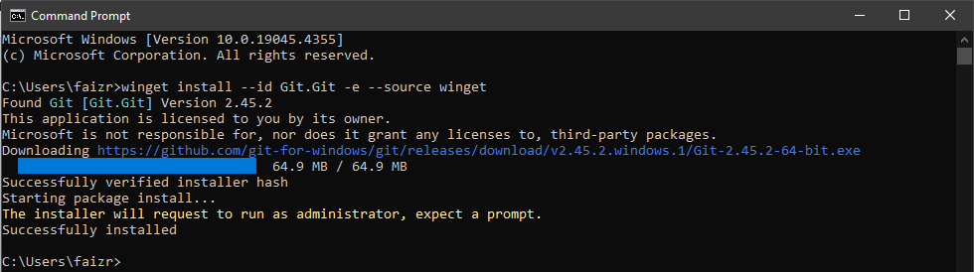

**Check Git Version**

Type git –version to check the git version in you system

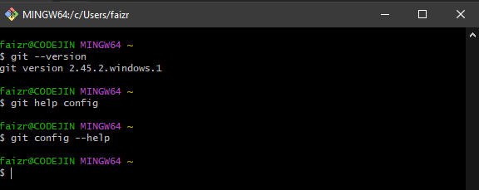

**Initiate Git repository**

Type git init in the directory you want to initialize the git repository.

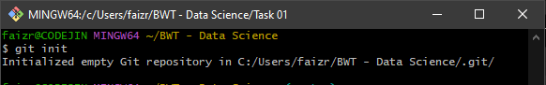

**Add Files**

Type git add “file name”, to add the file in your git repository.

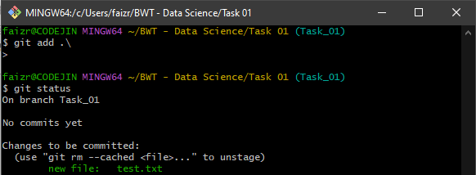

**Commit**

Type git commit –m “your message”, to add the commit in your repository.

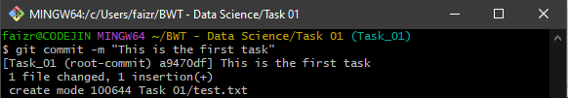

**Extra Mile**

Git is the version control, it helps to tract the version, track the changing made, track the changing made by who, helps to collaborate in coding work space.

**Help**

Type git config –help, it’ll show you how the current code work, how you can use.

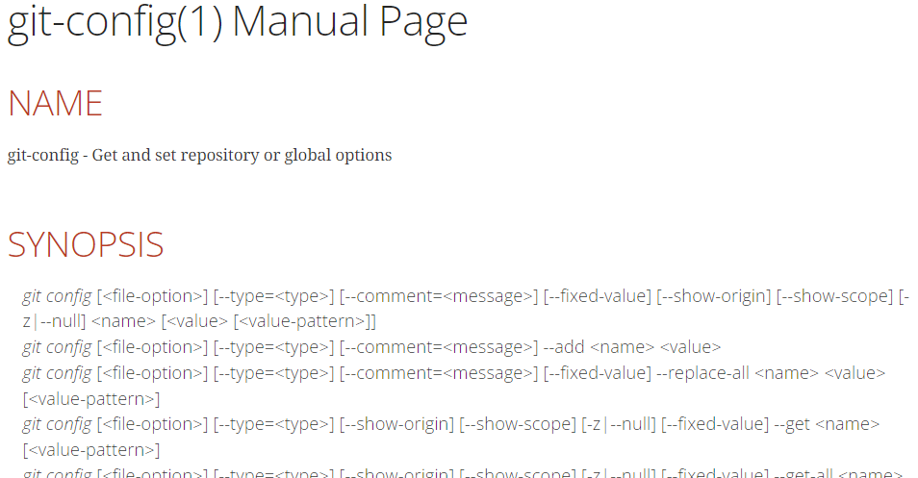

**Branches**

When we initiate the git repository, it by default creates a master branch. But suppose you have to create such a workflow, that you can’t rely on just the master branch, you need more child branches, as shown in the figure.

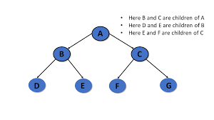

To create a child branch inside the master branch, you need to have subdirectory and then we can create a child branch.

Type git checkout – b “branch name”, to create the child branch. Branches helps us to create a hierarchy of out architecture of the program.

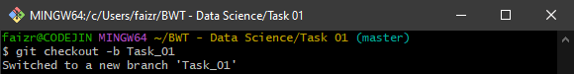

**Git Status**

Git status shows us after initiating the repo, what new files, changes made in the repository, it shows with red text, that things are changed and green shows that the changes have been added to the repository. Type git status to see the status of your repo.

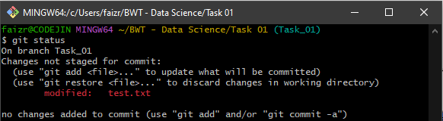

**Creating/Opening File**

Type touch “filename.extention”, to create a file/notepad. To open the file type notepad “filename.extention”.

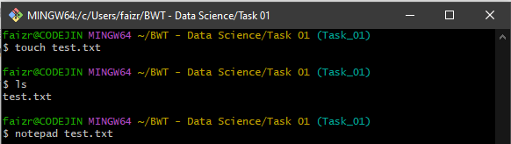

**Basic Commands**

Type dir or ls to see the list of directory in your current folder. Type mkdir “directory name”, to create a new directoy in your current folder. Type cd “.\directory name”, to change the directory.

